The chassis parameters:

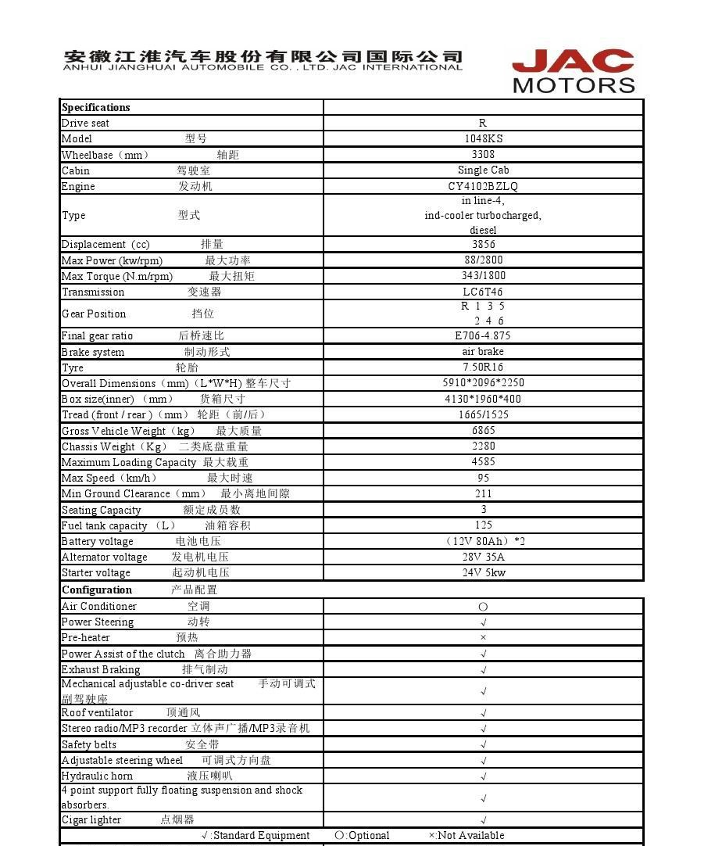

The truck box outside dimension :4200*2000*2000 mm
The refrigeration truck box Specification:
Specification:
- all the panel of the truck box are sandwitch structure.the glassfiber +PU +glassfiber.
- All the double surface sandwich polyurethane panel and door are 100mm thickness. the glass plate of FRP is 2.5mm for the outer and inner skin,the polyurethane foam density is 45-50kg/m³.
2.The Hardware(the door frame ,hinge,lock,handle) are all made for 304 stainless steel.
3.Aluminum alloy sides and 304 stainless steel wrap angle.
4.The rubber seal.

The lowest temperature : -30℃.
